**Introduction**

Our project, **"To Supply Leftover Food to the Poor,"** aims to combat hunger by connecting food donors with those in need using Salesforce. This solution streamlines the collection, management, and distribution of surplus food, minimizing waste while addressing food insecurity.

Leveraging Salesforce’s features like real-time tracking and donor management, the project ensures efficient and transparent coordination between donors, volunteers, and distribution cent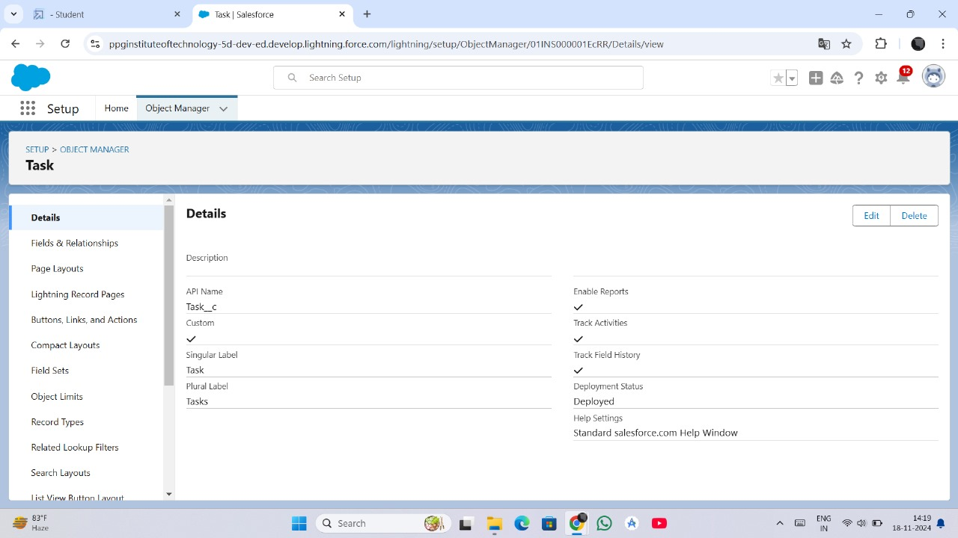ers. This initiative highlights how technology can drive meaningful social change, fostering a more sustainable and compassionate community.

**Salesforce Developer Account Creation**

To begin developing a Salesforce-based solution, the first step is to set up a Salesforce Developer account. This allows access to Salesforce’s robust platform, tools, and features. Below are the steps to create and activate a Salesforce Developer account:

**Step 1: Creating a Developer Account**

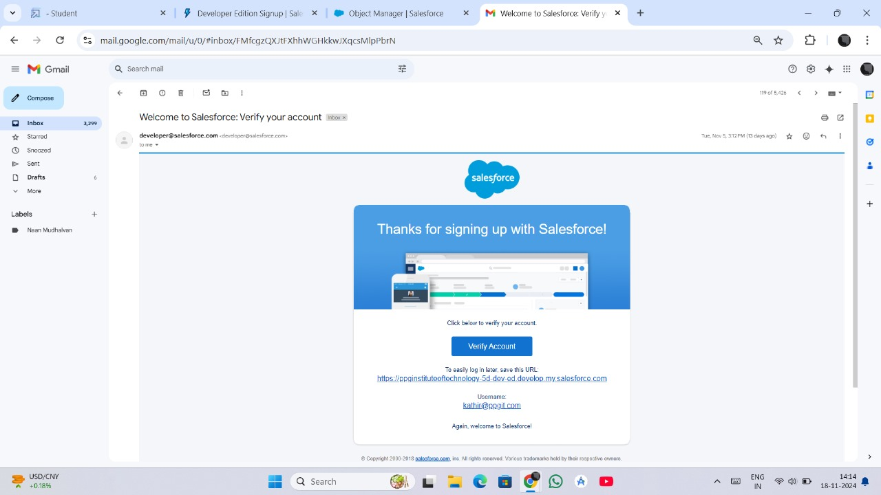

1. Go to the [Salesforce Developer Website](https://developer.salesforce.com).
2. Click on the **"Sign Up"** button.
3. Fill out the registration form with the required details:
   * **First Name** and **Last Name**
   * **Email Address** (use an accessible email for account activation)
   * **Company Name** (can use "Individual" if not associated with an organization)
   * **Job Title** and **Country/Region**
   * **Username** (must be in the format of an email address, e.g., username@example.com)
4. Accept the Salesforce Terms of Use and click **"Sign Up."**

**Step 2: Account Activation**

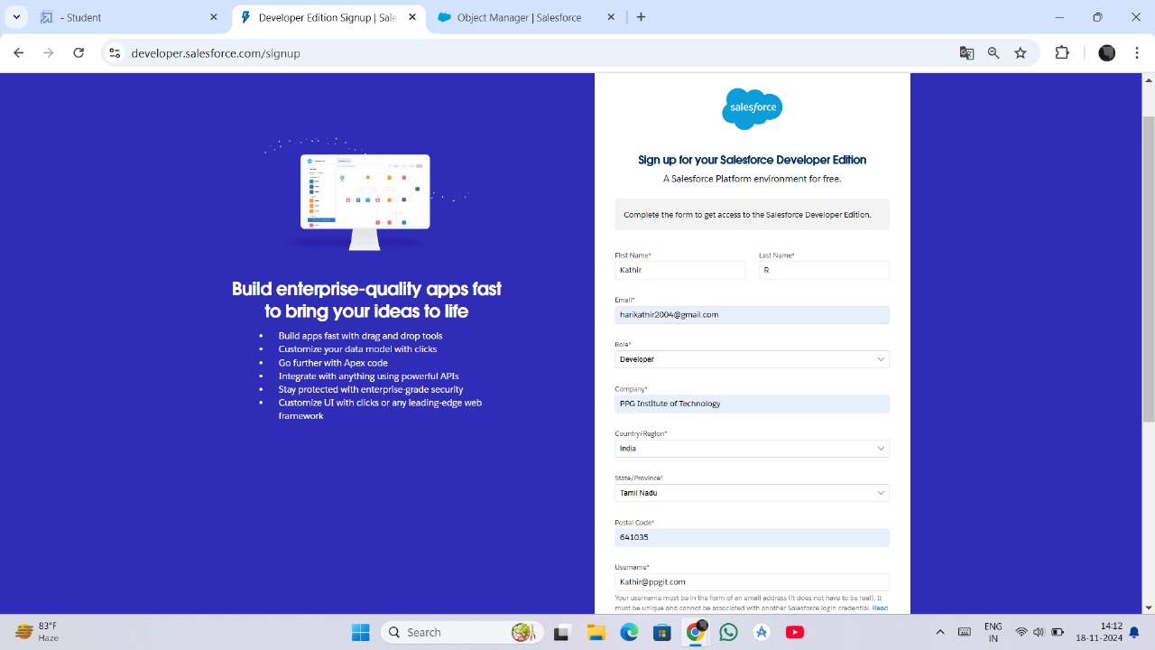

1. Check the email inbox for the activation email from Salesforce.
2. Open the email and click the **"Verify Account"** or **"Activate Now"** link provided.
3. Set a secure password for your account and choose a security question for account recovery.
4. Once completed, you will be redirected to your Salesforce Developer dashboard, confirming successful account creation and activation.

These steps establish your access to Salesforce's development tools and features, enabling you to start building your application.

**2. Object Creation in Salesforce**

For the **"To Supply Leftover Food to the Poor"** project, we use custom objects in Salesforce to manage the data effectively. Below are the steps to create and configure the required objects for the project:

1. **Venue Object**

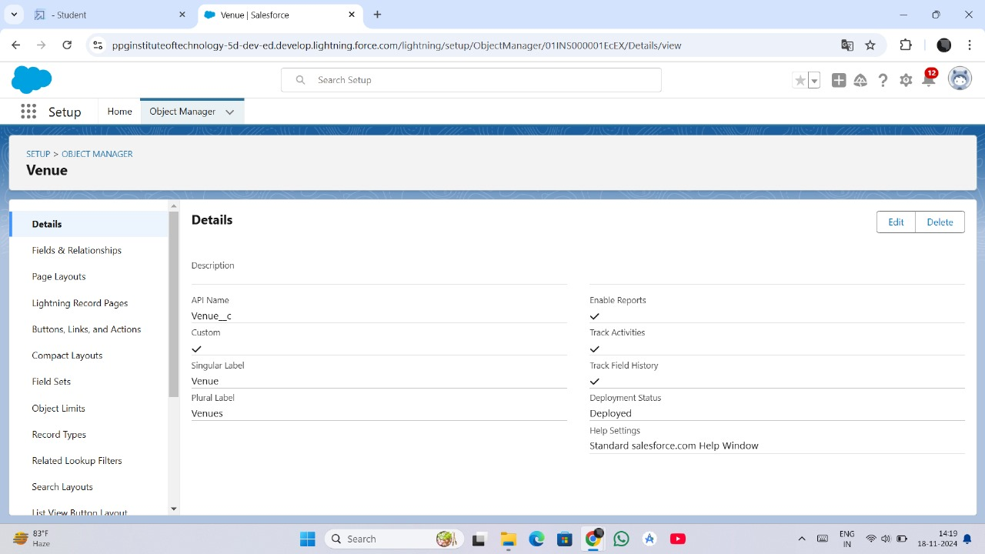

The **Venue Object** stores information about the locations providing leftover food, such as restaurants or event spaces. This object includes fields like:

* **Venue Name**: The name of the food donor.
* **Address**: Location of the venue.
* **Contact Information**: Point of contact for coordination.

By creating this object, we centralize details about food sources, making it easier to track and manage donors.

1. **Drop-Off Point Object**

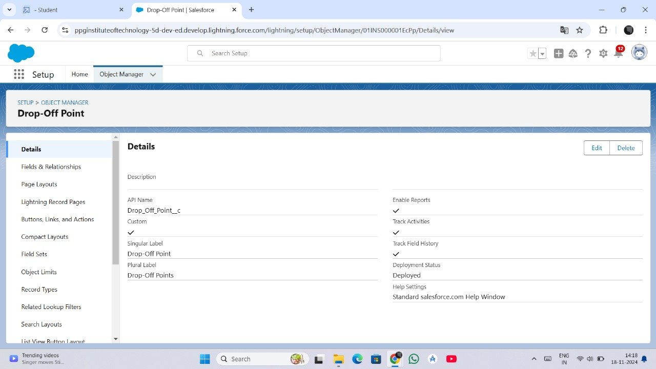

The **Drop-Off Point Object** represents locations where food will be delivered for further distribution to the needy. It includes fields such as:

* **Location**: Address or area of the drop-off point.
* **Capacity**: Amount of food it can accommodate.
* **Contact Details**: To manage logistics at the drop-off point.

This object ensures organized handling of food distribution by specifying clear delivery points.

1. **Task Object**

The **Task Object** is used to manage actions required in the project, such as food pickup, delivery, and coordination activities. Fields like:

* **Task Name**: Title of the task (e.g., "Food Pickup from Venue A").
* **Assigned To**: Volunteer or team handling the task.
* **Deadline**: To track task completion timelines.
* **Status**: Current status of the task (e.g., "Pending," "In Progress," "Completed").

This object ensures efficient task management and accountability.



**4. Volunteer Object**

The **Volunteer Object** keeps details about the individuals participating in the project. Key fields include:

* **Name**: Name of the volunteer.
* **Contact Number and Email**: For communication purposes.
* **Availability**: To assign tasks based on their schedule.
* **Assigned Tasks**: Tasks linked to the volunteer.

This object streamlines volunteer management and enables efficient task assignment.

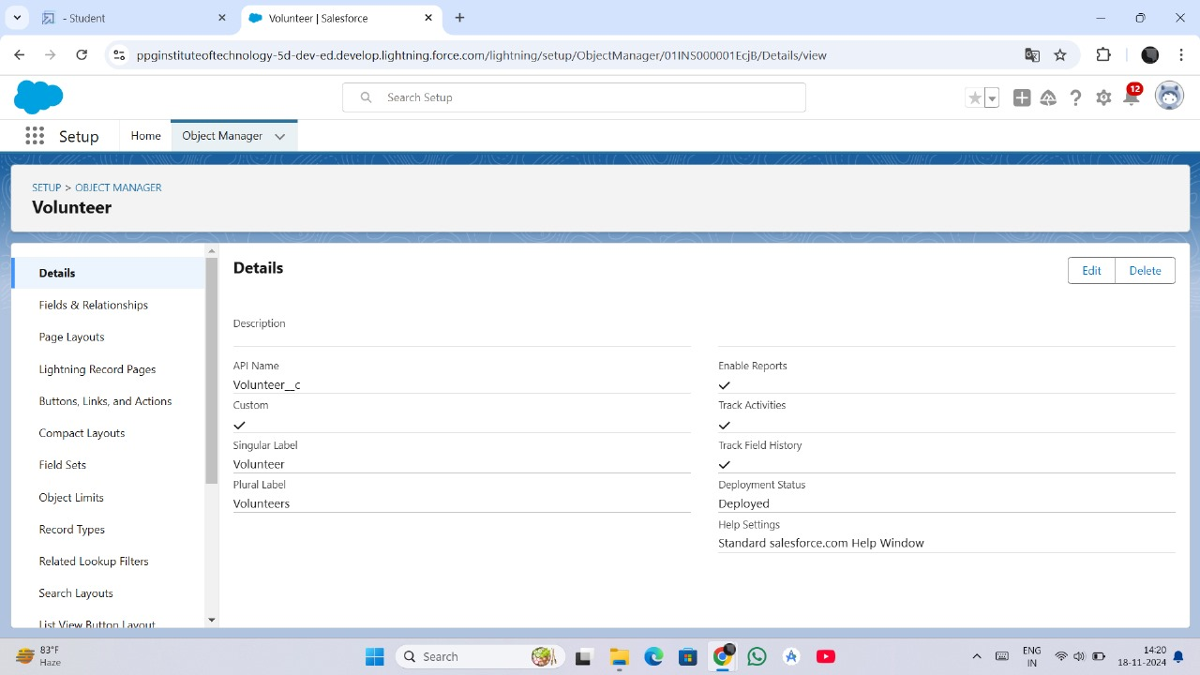

1. **Execution Detail Object**

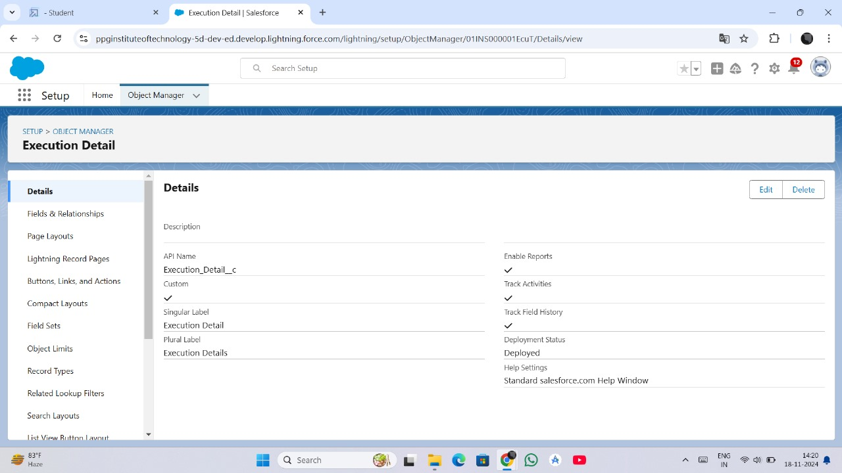

The **Execution Detail Object** tracks the progress and completion of activities, ensuring transparency and accountability. It includes fields such as:

* **Execution ID**: Unique identifier for each execution instance.
* **Venue and Volunteer**: Details about the source and person responsible.
* **Drop-Off Point**: Delivery location.
* **Completion Status**: Indicates whether the activity is complete.
* **Date & Time**: Timestamp for better tracking.

This object provides a comprehensive overview of the project's execution and helps monitor its success.

**Tab Creation in Salesforce**

Tabs in Salesforce provide a user-friendly way to access and interact with data stored in custom objects. For the **"To Supply Leftover Food to the Poor"** project, we create custom tabs for each object to simplify navigation and data management.

**Steps to Create Tabs for Each Object**

1. **Go to Setup**:  
   Log in to your Salesforce Developer account and navigate to the **Setup** menu.
2. **Search for Tabs**:  
   In the **Quick Find** box, type **Tabs** and select **Tabs** from the results.
3. **Click on New Tab**:  
   Under the **Custom Object Tabs** section, click **New** to create a tab.
4. **Select the Object**:  
   Choose the object for which you want to create the tab (e.g., Venue, Drop-Off Point, etc.).
5. **Choose a Tab Style**:  
   Select a visual style for the tab. You can either pick a default Salesforce icon or upload a custom image for better representation.
6. **Set Tab Visibility**:
   * Set the tab visibility for profiles, ensuring relevant users can access the tab.
   * For example, make tabs visible to system administrators and project volunteers.
7. **Add Tab to Apps**:
   * Add the tab to the **Salesforce App** or a custom app for easy access.
   * This step ensures the tab appears in the app's navigation bar.
8. **Save**:  
   Save the tab configuration, and the tab will be accessible in the app.

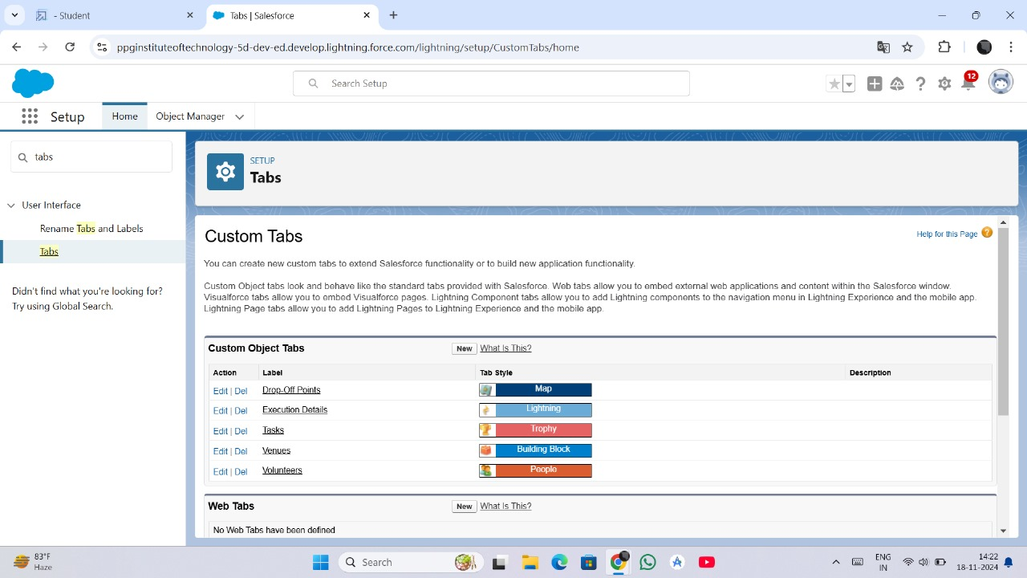

**Create Tabs for All Objects**

* **Venue Tab**: Provides access to details of all venues donating food.
* **Drop-Off Point Tab**: Displays information about food distribution points.
* **Task Tab**: Allows users to view and manage all assigned tasks.
* **Volunteer Tab**: Centralized location for managing volunteer data.
* **Execution Detail Tab**: Shows the execution history and progress of the project activities.

**Creating a Lightning App and Lightning App Page**

In Salesforce, Lightning Apps enhance the user experience by providing an intuitive interface to manage data and processes. For the **"To Supply Leftover Food to the Poor"** project, we will create a custom Lightning App and a Lightning App Page to centralize operations.

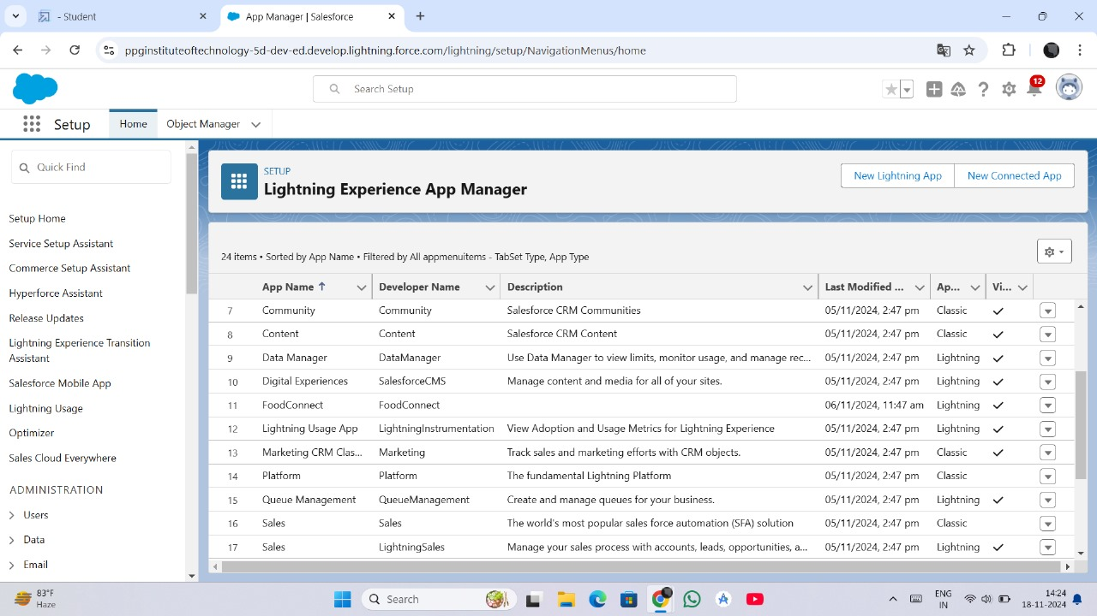

**1. Create a Lightning App**

**Step 1: Navigate to App Manager**

1. Log in to Salesforce and go to **Setup**.
2. In the **Quick Find** box, search for **App Manager** and select it.

**Step 2: Create a New Lightning App**

1. Click the **New Lightning App** button in the App Manager.
2. Enter the following details:
   * **App Name**: To Supply Leftover Food to Poor
   * **Developer Name**: Automatically populated, or enter a unique identifier.
   * **Description**: A platform to manage leftover food collection and distribution.

**Step 3: Customize the App Options**

1. Choose an **App Icon** and a primary color theme.
2. Select additional options such as **Setup for Lightning Experience Only** or **Navigation Bar Customization** if needed.

**Step 4: Configure Navigation Items**

1. Add relevant tabs (Venue, Drop-Off Point, Task, Volunteer, and Execution Detail) to the app’s navigation bar for easy access.
2. Reorder tabs for user convenience, with the most frequently used ones displayed first.

**Step 5: Assign App Visibility**

1. Define the user profiles that can access the app (e.g., System Administrators, Volunteers).
2. Save and finish the app creation process.
3. **Create a Lightning App Page**

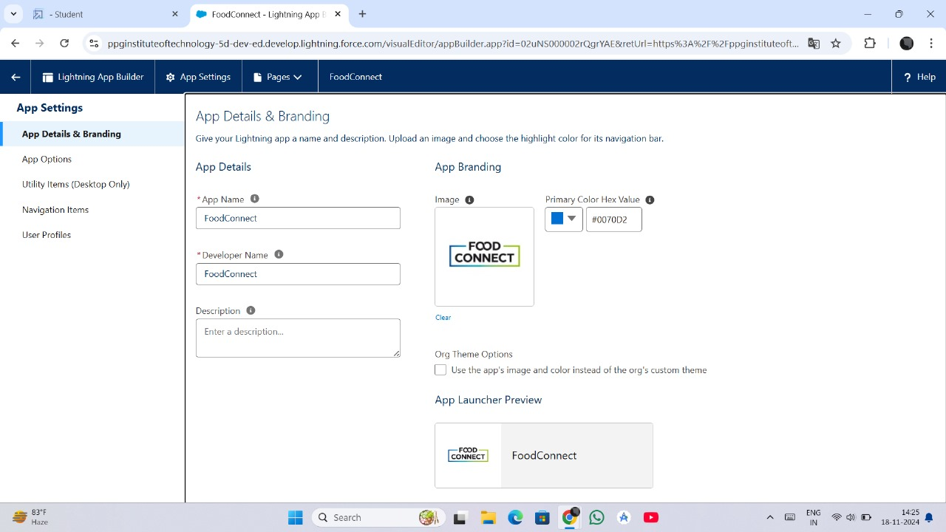

A Lightning App Page organizes essential data and components for streamlined workflows.

**Step 1: Navigate to App Builder**

1. From **Setup**, search for **Lightning App Builder** in the **Quick Find** box.
2. Click **New** and select **App Page** as the type of Lightning page.

**Step 2: Design the Layout**

1. Choose a layout template for the app page, such as:
   * **Single Region**: For a simple page.
   * **Two or Three Columns**: To display multiple components side by side.
2. Click **Next** to proceed.

**Step 3: Add Components to the Page**

1. Drag and drop components into the layout. Include:
   * **Tabs or Lists**: For objects like Venues, Drop-Off Points, etc.
   * **Charts and Dashboards**: To display reports on food collected and distributed.
   * **Record Details**: To view detailed information for selected records.
2. Customize each component’s settings to display relevant data.

**Step 4: Save and Activate the Page**

1. Save the app page and click **Activate**.
2. Assign the page to a specific app or make it the default home page for selected profiles.

**Creation of Relationship Fields in Objects**

Relationship fields in Salesforce are used to establish connections between objects, enabling seamless data integration and better data management. For the **"To Supply Leftover Food to the Poor"** project, various relationship fields are created to link objects effectively. Below are the steps for each relationship creation:

**1. Creation of Master-Detail Relationship Field on Volunteer Object**

1. Go to **Setup** and click **Object Manager**.
2. Search for **Volunteer** in the search bar and select the object.
3. Click on **Fields & Relationships**, then click **New**.
4. Select **Master-Detail Relationship** and click **Next**.
5. Choose the related object **Drop-Off Point** and click **Next**.
6. Enter the following details:
   * **Field Name**: Drop_Off_Point
   * **Field Label**: Auto-generated.
7. Click **Next >> Next >> Save**.

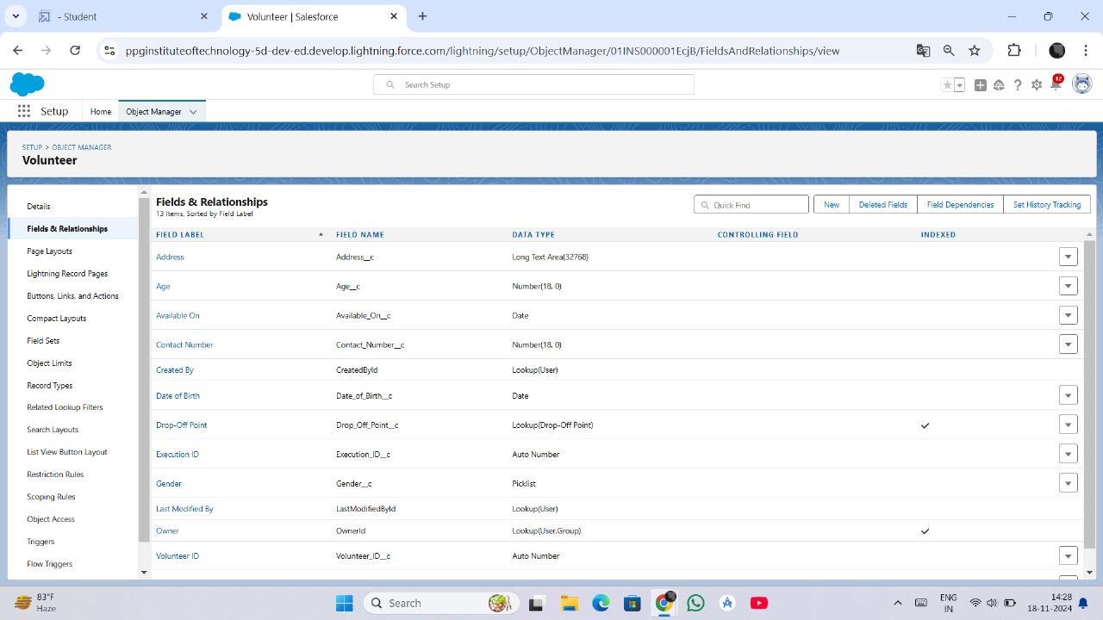

**2. Creation of Master-Detail Relationship Field on Execution Details Object (Volunteer)**

1. Go to **Setup** and click **Object Manager**.
2. Search for **Execution Details** in the search bar and select the object.
3. Click on **Fields & Relationships**, then click **New**.
4. Select **Master-Detail Relationship** and click **Next**.
5. Choose the related object **Volunteer** and click **Next**.
6. Enter the following details:
   * **Field Name**: Volunteer
   * **Field Label**: Auto-generated.
7. Click **Next >> Next >> Save**.

**3. Creation of Master-Detail Relationship Field on Execution Details Object (Task)**

1. Go to **Setup** and click **Object Manager**.
2. Search for **Execution Details** in the search bar and select the object.
3. Click on **Fields & Relationships**, then click **New**.
4. Select **Master-Detail Relationship** and click **Next**.
5. Choose the related object **Task** and click **Next**.
6. Enter the following details:
   * **Field Name**: Task
   * **Field Label**: Auto-generated.
7. Click **Next >> Next >> Save**.

**4. Creation of Lookup Relationship Field on Drop-Off Point Object**

1. Go to **Setup** and click **Object Manager**.
2. Search for **Task** in the search bar and select the object.
3. Click on **Fields & Relationships**, then click **New**.
4. Select **Lookup Relationship** and click **Next**.
5. Choose the related object **Drop-Off Point** and click **Next**.
6. Enter the following details:
   * **Field Name**: Venue
   * **Field Label**: Venue__c.
7. Click **Next >> Next >> Save**.

**5. Creation of Lookup Relationship Field on Task Object (Venue)**

1. Go to **Setup** and click **Object Manager**.
2. Search for **Task** in the search bar and select the object.
3. Click on **Fields & Relationships**, then click **New**.
4. Select **Lookup Relationship** and click **Next**.
5. Choose the related object **Venue** and click **Next**.
6. Enter the following details:
   * **Field Name**: Sponsored By
   * **Field Label**: Auto-generated.
7. Click **Next >> Next >> Save**.

**6. Creation of Lookup Relationship Field on Task Object (Drop-Off Point)**

1. Go to **Setup** and click **Object Manager**.
2. Search for **Task** in the search bar and select the object.
3. Click on **Fields & Relationships**, then click **New**.
4. Select **Lookup Relationship** and click **Next**.
5. Choose the related object **Drop-Off Point** and click **Next**.
6. Enter the following details:
   * **Field Name**: Drop-Off Point
   * **Field Label**: Auto-generated.
7. Click **Next >> Next >> Save**.

**Creation of a Flow to Create a Record in the Venue Object**

**Flows** in Salesforce provide a user-friendly way to automate processes without extensive coding. For the **"To Supply Leftover Food to the Poor"** project, we will create a flow that allows users to create a new record in the **Venue** object. This ensures data entry is streamlined and consistent.

**Steps to Create the Flow**

**Step 1: Navigate to Flow Builder**

1. Log in to your Salesforce Developer account.
2. Go to **Setup**, and in the **Quick Find** box, search for **Flows**.
3. Click **Flows** under **Process Automation** and then click **New Flow**.

**Step 2: Select Flow Type**

1. Choose **Screen Flow** to create an interactive flow for users.
2. Click **Create** to open the Flow Builder.

**Step 3: Add a Screen Element**

1. Drag the **Screen** element from the toolbox onto the canvas.
2. Configure the screen to collect data for the **Venue** object:
   * Add fields for **Venue Name**, **Address**, **Contact Number**, and any other required fields.
   * Use components like **Text**, **Phone**, or **Email** based on the field types.
3. Provide a name for the screen, e.g., **Enter Venue Details**, and click **Done**.

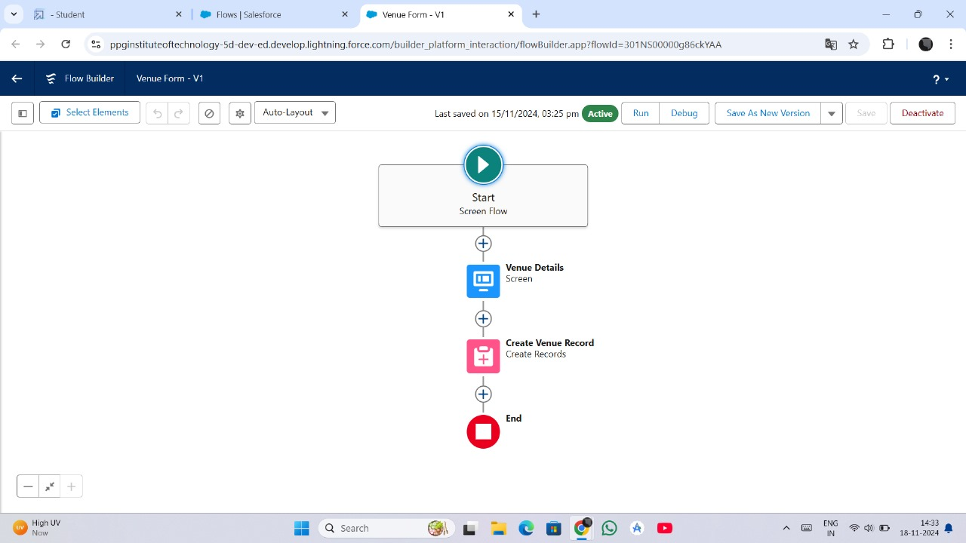

**Step 4: Add a Create Records Element**

1. Drag the **Create Records** element onto the canvas, following the screen element.
2. Configure the **Create Records** element:
   * **Label**: Create Venue Record.
   * **Create a Record For**: Select **Venue**.
   * **How to Set Record Fields**: Choose **Use separate resources and literal values**.
3. Map the inputs from the screen to the Venue object fields. For example:
   * **Venue Name** → Screen Input: Venue Name
   * **Address** → Screen Input: Address
   * **Contact Number** → Screen Input: Contact Number
4. Click **Done**.

**Step 5: Connect Elements**

1. Connect the **Start** element to the **Screen** element.
2. Connect the **Screen** element to the **Create Records** element.

**Step 6: Save and Activate the Flow**

1. Click **Save** and provide a name for the flow, e.g., **Create Venue Record Flow**.
2. Click **Activate** to make the flow available for use.

**Creation of a Trigger in Salesforce**

A **trigger** in Salesforce is an Apex script that executes before or after specific events occur on a record. For the **"To Supply Leftover Food to the Poor"** project, we will create a trigger to automate actions based on operations performed on an object.

**Steps to Create a Trigger**

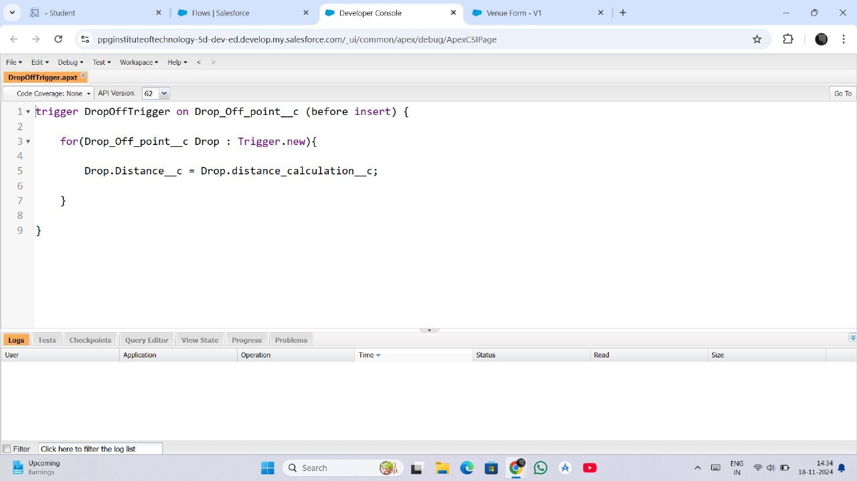

**Step 1: Log into Trailhead**

1. Open your Trailhead Playground and log in with your Salesforce Developer account credentials.
2. Navigate to the **gear icon** in the top-right corner and select **Developer Console**.

**Step 2: Open the Developer Console**

1. The Developer Console will open in a new window.
2. From the toolbar, click on the **File** menu.

**Step 3: Create a New Trigger**

1. In the **File** menu, select **New >> Apex Trigger**.
2. Provide the following details:
   * **Trigger Name**: Enter a descriptive name (e.g., VenueTrigger or TaskAutomationTrigger).
   * **Object**: Select the object on which the trigger will run (e.g., Venue, Task).

**Step 4: Define the Trigger**

1. Once the trigger file is created, a default trigger structure is generated.
2. Modify the code to suit the required automation. For example:

apex

Copy code

trigger VenueTrigger on Venue__c (before insert, before update) {

for (Venue__c venue : Trigger.new) {

if (venue.Contact_Number__c == null) {

venue.addError('Contact Number is mandatory.');

}

}

}

**Explanation**:

* The above example ensures that the **Contact Number** field is not left blank when creating or updating a Venue record.
* Use **Trigger.new** to access the new values of the record.

**Step 5: Save and Test the Trigger**

1. Save the trigger in the Developer Console.
2. Navigate to the **Venue** object (or the selected object) and try creating or updating a record to test the trigger’s functionality.

**Creation of Profiles in Salesforce**

Profiles in Salesforce are used to define the level of access and permissions a user has for data and features. For the **"To Supply Leftover Food to the Poor"** project, we will create a custom profile for NGOs to manage their activities efficiently while ensuring data security and access control.

1. **Creation of User 1 (NGO Manager)**

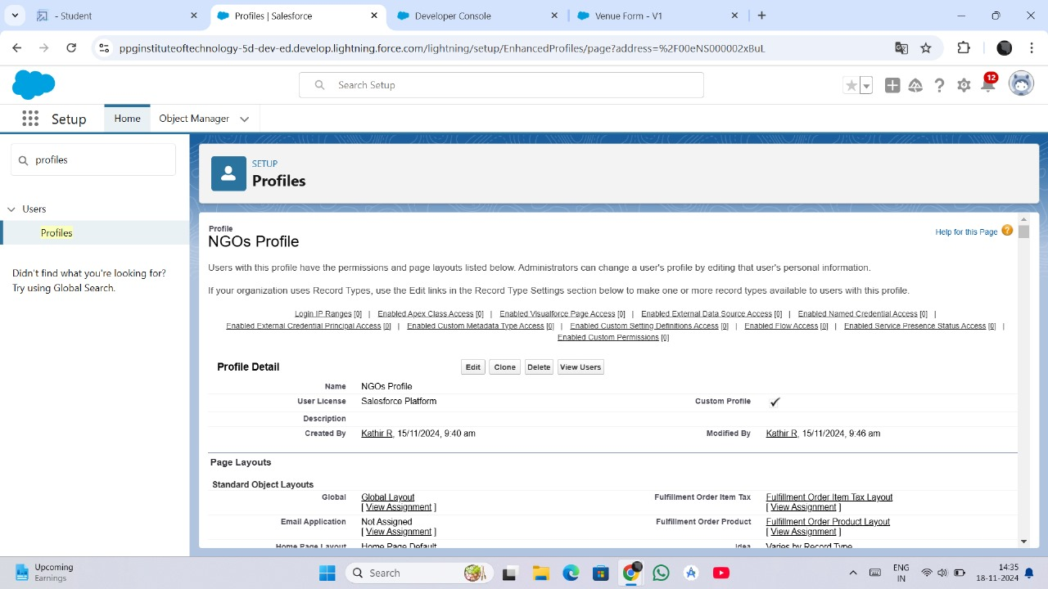

1. On the **Users** page, click **New User**.
2. Fill in the required fields:
   * **First Name**: NGO
   * **Last Name**: Manager
   * **Alias**: NGOMan
   * **Email**: ngo.manager@example.com
   * **Username**: ngo.manager@example.com
   * **Nickname**: NGOMan
   * **Role**: Choose a suitable role (e.g., Manager).
   * **Profile**: Select **NGOs Profile** (created earlier).
   * **License**: Salesforce Platform.
3. Click **Save**.

**2.Creation of User 2 (Volunteer Coordinator)**

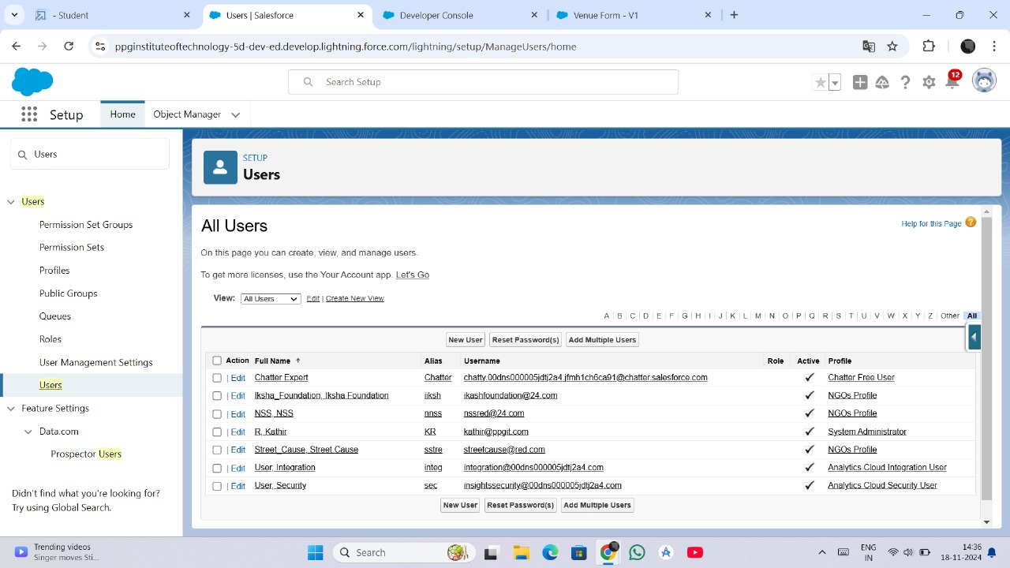

1. On the **Users** page, click **New User**.
2. Fill in the required fields:
   * **First Name**: Volunteer
   * **Last Name**: Coordinator
   * **Alias**: VolCoord
   * **Email**: volunteer.coordinator@example.com
   * **Username**: volunteer.coordinator@example.com
   * **Nickname**: VolCoord
   * **Role**: Choose a suitable role (e.g., Coordinator).
   * **Profile**: Select **Standard Platform User**.
   * **License**: Salesforce Platform.
3. Click **Save**.

**3. Creation of User 3 (Field Volunteer)**

1. On the **Users** page, click **New User**.
2. Fill in the required fields:
   * **First Name**: Field
   * **Last Name**: Volunteer
   * **Alias**: FieldVol
   * **Email**: field.volunteer@example.com
   * **Username**: field.volunteer@example.com
   * **Nickname**: FieldVol
   * **Role**: Choose a suitable role (e.g., Volunteer).
   * **Profile**: Select **Standard Platform User**.
   * **License**: Salesforce Platform.
3. Click **Save**.

**1. Creation of Public Group - 1 (NGO Managers Group)**

**Purpose**: This group is intended for NGO Managers who oversee the overall operation of food distribution.

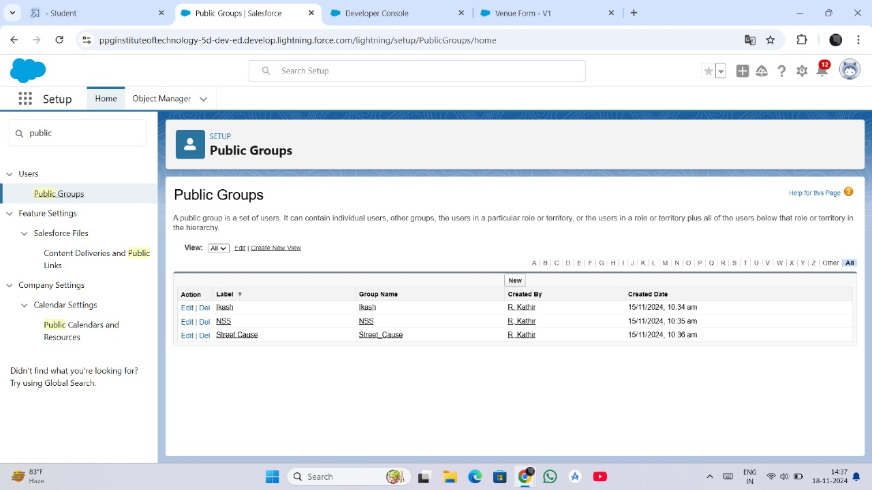

1. **Navigate to Setup**:
   * Log in to Salesforce.
   * Go to **Setup**, and in the **Quick Find** bar, type **Public Groups**.
   * Select **Public Groups** from the results.
2. **Click on New**:
   * Click the **New** button to create a new group.
3. **Enter Group Details**:
   * **Label**: NGO Managers Group
   * **Group Name**: NGO_Managers_Group
   * **Search for Users, Roles, or Other Public Groups**:
     + Add **NGO Manager (User 1)** and any other relevant users or roles to the group.
   * Click **Save**.

**2. Creation of Public Group - 2 (Field Volunteers Group)**

**Purpose**: This group is intended for field volunteers responsible for task execution and food distribution.

1. **Navigate to Setup**:
   * Follow the same steps as above to access the **Public Groups** page.
2. **Click on New**:
   * Click the **New** button to create a second group.
3. **Enter Group Details**:
   * **Label**: Field Volunteers Group
   * **Group Name**: Field_Volunteers_Group
   * **Search for Users, Roles, or Other Public Groups**:
     + Add **Field Volunteer (User 3)** and other relevant users or roles to the group.
   * Click **Save**.

**Creation of Report Types in Salesforce**

In Salesforce, **Report Types** define the structure and data relationships available for generating reports. For the **"To Supply Leftover Food to the Poor"** project, creating custom report types helps in analyzing critical data such as Venue details, Task assignments, and Volunteer performance.

**Steps to Create Report Types**

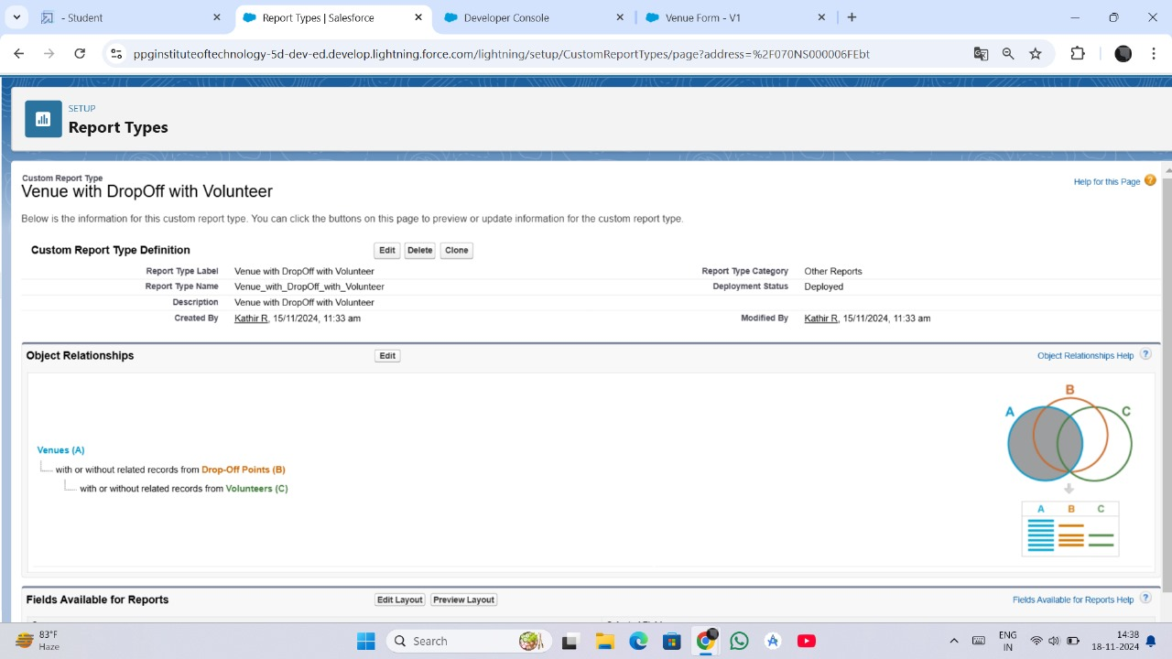

**Step 1: Navigate to Report Types**

1. Log in to Salesforce and go to the **Setup** page.
2. In the **Quick Find** bar, type **Report Types** and select **Report Types** from the results.

**Step 2: Click on New Custom Report Type**

1. Click the **New Custom Report Type** button.

**Step 3: Define the Report Type Details**

1. **Primary Object**: Select the primary object for the report (e.g., **Venue**, **Task**, **Volunteer**).
2. **Report Type Label**: Enter a descriptive name for the report type (e.g., **Venue and Drop-Off Points Report**).
3. **Report Type Name**: Automatically generated based on the label.
4. **Description**: Enter a brief description of the report type’s purpose (e.g., "Tracks venue details and associated drop-off points").
5. **Store in Category**: Choose the category where the report type will be saved (e.g., Other Reports).
6. **Deployment Status**: Set the status to **Deployed** to make the report type available for use.
7. Click **Next**.

**Step 4: Define Object Relationships**

1. **Add Related Objects**:
   * Select related objects to include additional data in the report. For example:
     + **Venue** (Primary Object) with **Drop-Off Point** (Related Object).
   * Define the relationship type (e.g., "Each A may or may not have related B").
2. Click **Save**.

**Creation of Report: Venue with Drop-Off Point and Volunteer**

Reports in Salesforce help visualize and analyze data effectively. For the **"To Supply Leftover Food to the Poor"** project, a report combining Venue, Drop-Off Point, and Volunteer data provides insights into the food distribution network and volunteer participation.

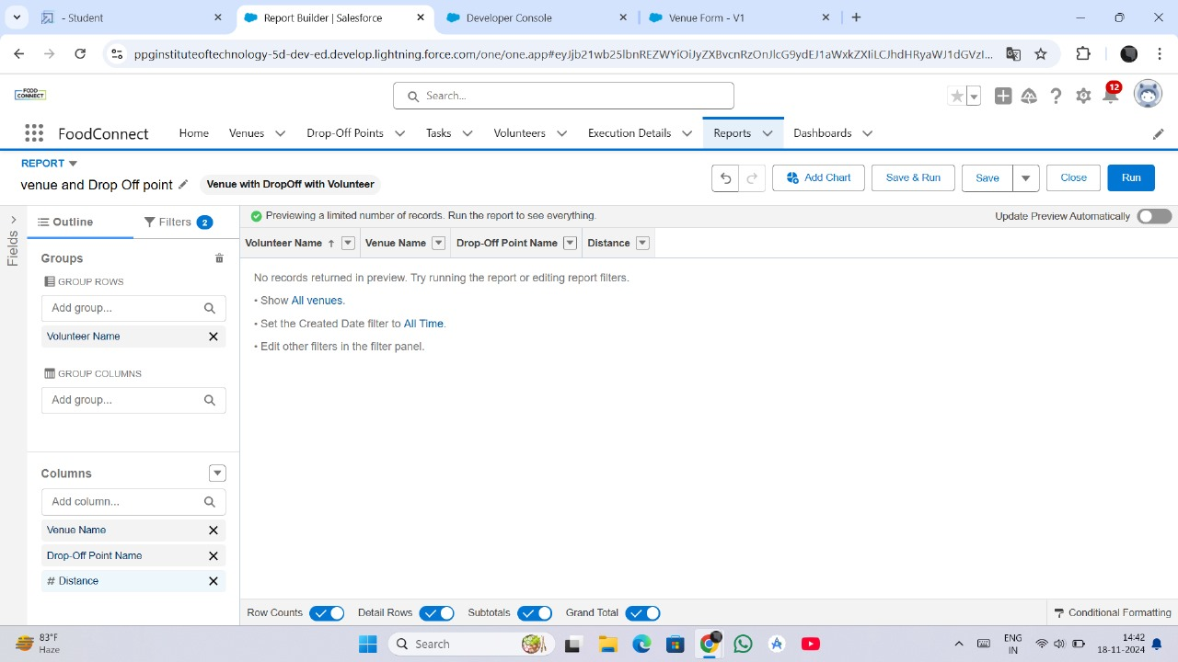

**Steps to Create the Report**

**Step 1: Navigate to the Reports Tab**

1. Log in to Salesforce.
2. Click on the **App Launcher** and select **Reports**.
3. In the Reports page, click **New Report**.

**Step 2: Select a Report Type**

1. In the **Choose Report Type** window:
   * Search for and select the **Venue with Drop-Off Point and Volunteer** report type.
   * Click **Continue**.

**Step 3: Configure the Report**

1. **Add Filters**:
   * Set the filters to include relevant data:
     + **Status**: Active
     + **Date**: Select a date range to filter data (e.g., Current Month).
2. **Add Columns**:
   * Include the following columns to display key data:
     + **Venue Name**
     + **Drop-Off Point Location**
     + **Volunteer Name**
     + **Task Description**
     + **Task Status**
3. **Group Data**:
   * Group the report by **Venue Name** to categorize data by venue.
4. **Sort Data**:
   * Sort the report by **Task Status** or **Drop-Off Point Location** as needed.

**Step 4: Save and Run the Report**

1. Click **Save & Run** to generate the report.
2. Enter report details:
   * **Report Name**: Venue with Drop-Off Point and Volunteer
   * **Description**: Tracks venues, drop-off locations, and volunteer participation for food distribution.
   * **Folder**: Save the report in a shared folder for access by team members.

**Creation of Report: Volunteers with Execution Details and Tasks**

In the **"To Supply Leftover Food to the Poor"** project, creating a report that combines Volunteer data with Execution Details and Tasks helps in tracking volunteer activities, task progress, and execution outcomes.

**Steps to Create the Report**

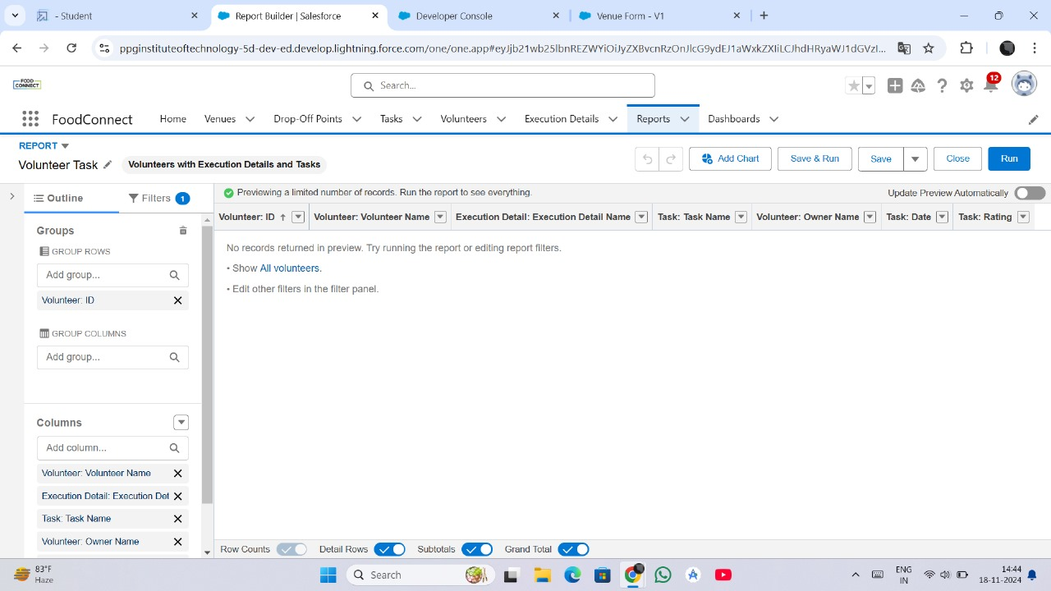

**Step 1: Navigate to Reports Tab**

1. Log in to Salesforce and click on the **App Launcher**.
2. Select **Reports** from the menu.
3. Click **New Report**.

**Step 2: Select a Report Type**

1. In the **Choose Report Type** window, search for and select **Volunteer with Execution Details and Task** report type.
2. Click **Continue**.

**Step 3: Customize the Report**

1. **Apply Filters**:
   * Filter by **Task Status** (e.g., Completed, In Progress).
   * Filter by **Date** (e.g., Current Month, Last Week).
2. **Select Columns** to include:
   * **Volunteer Name**
   * **Task Description**
   * **Execution Details (e.g., food quantity, task progress)**
   * **Task Status**
   * **Drop-Off Point**
3. **Group Data**:
   * Group by **Volunteer Name** to see task assignments per volunteer.

**Step 4: Save and Run the Report**

1. Click **Save & Run**.
2. Provide a name for the report: **Volunteers with Execution Details and Tasks**.
3. Add a brief **Description**: "Tracks volunteers' tasks, execution progress, and outcomes".
4. Save the report to a shared folder.

**Adding Venue and Drop-Off Point Report to the Dashboard**

In the **"To Supply Leftover Food to the Poor"** project, adding a **Venue and Drop-Off Point Report** to a Salesforce Dashboard enables project stakeholders to have a visual and real-time overview of the distribution venues and drop-off points. This helps in tracking the status and improving the operational efficiency of the food distribution process.

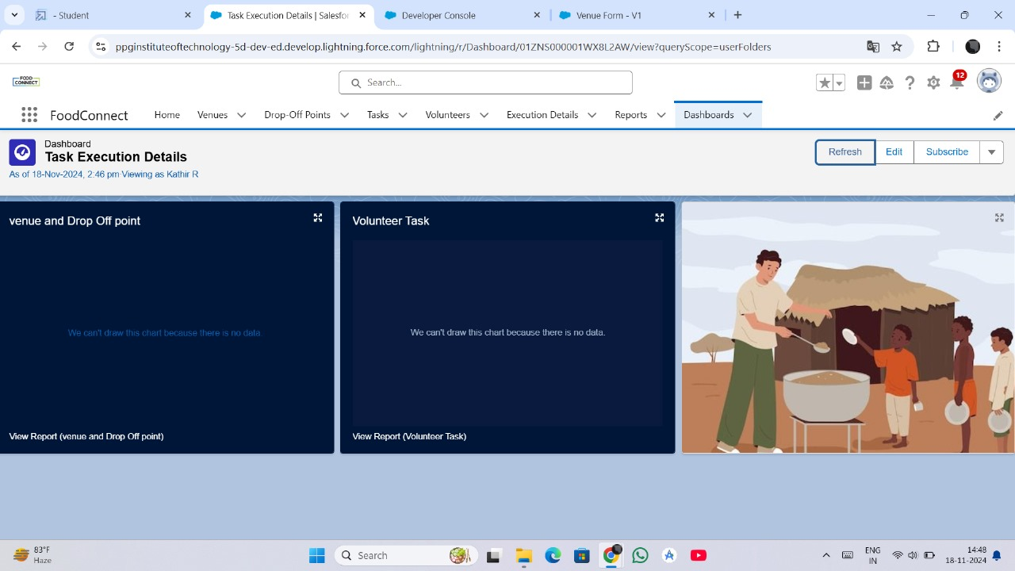

**Steps to Add Venue and Drop-Off Point Report to the Dashboard**

**Step 1: Create the Report**

1. Ensure that the **Venue and Drop-Off Point Report** is already created in the **Reports** tab.
2. If not, follow the steps to create the report, including selecting the correct report type, adding necessary fields, and grouping the data.

**Step 2: Navigate to the Dashboard Tab**

1. Go to the **App Launcher** and select **Dashboards**.
2. Click **Create New Dashboard** or select an existing dashboard to which you want to add the report.

**Step 3: Select a Dashboard Layout**

1. Choose a **Dashboard Layout** that fits your needs (e.g., 1-Column, 2-Column).
2. Provide a name for the dashboard, such as **Food Distribution Overview**.
3. Choose the **Folder** to save the dashboard in (e.g., a shared folder for the project team).

**Step 4: Add Report to the Dashboard**

1. Click **Create** or **Edit** on the chosen dashboard.
2. Click on the **+Component** button to add a new component to the dashboard.
3. In the **Select Report** section, search for the **Venue and Drop-Off Point Report**.
4. Select the report and choose the **Component Type** (e.g., Chart, Table, or Gauge).
5. Configure the chart or table settings to display the data clearly (e.g., bar chart, pie chart, or summary table).

**Step 5: Customize the Component**

1. Customize the **component title** and other display options (e.g., add filters, colors).
2. Resize and reposition the component within the dashboard layout.

**Adding Volunteer Task Report to the Dashboard**

To provide an overview of volunteer tasks and their progress, you can add the **Volunteer Task Report** to the Salesforce dashboard.



**Steps:**

1. **Create the Report**:
   * Ensure the **Volunteer Task Report** is created with relevant data such as volunteer names, task descriptions, and task statuses.
2. **Navigate to the Dashboard**:
   * Go to the **Dashboards** tab and select an existing dashboard or create a new one.
3. **Add Report to the Dashboard**:
   * Click **+ Component**, choose the **Volunteer Task Report**, and select a component type (e.g., table, chart).
   * Customize the component's appearance and settings to make it more informative.
4. **Save and Share**:
   * Save the dashboard and share it with relevant users or teams.

**2. Adding a Picture to the Dashboard (Optional)**

Visual elements such as logos or project-related images can be added to dashboards for a more engaging user experience.

**Steps:**

1. Go to the **Dashboard** and click on **Edit**.
2. In the **Component Section**, select **Image** as the component type.
3. Upload the image (e.g., logo of the project or relevant visuals like food distribution).
4. Resize and position the image on the dashboard layout.
5. Click **Save**.

This allows for a more personalized and professional-looking dashboard, enhancing the user interface.

1. **Creation of Sharing Rules**

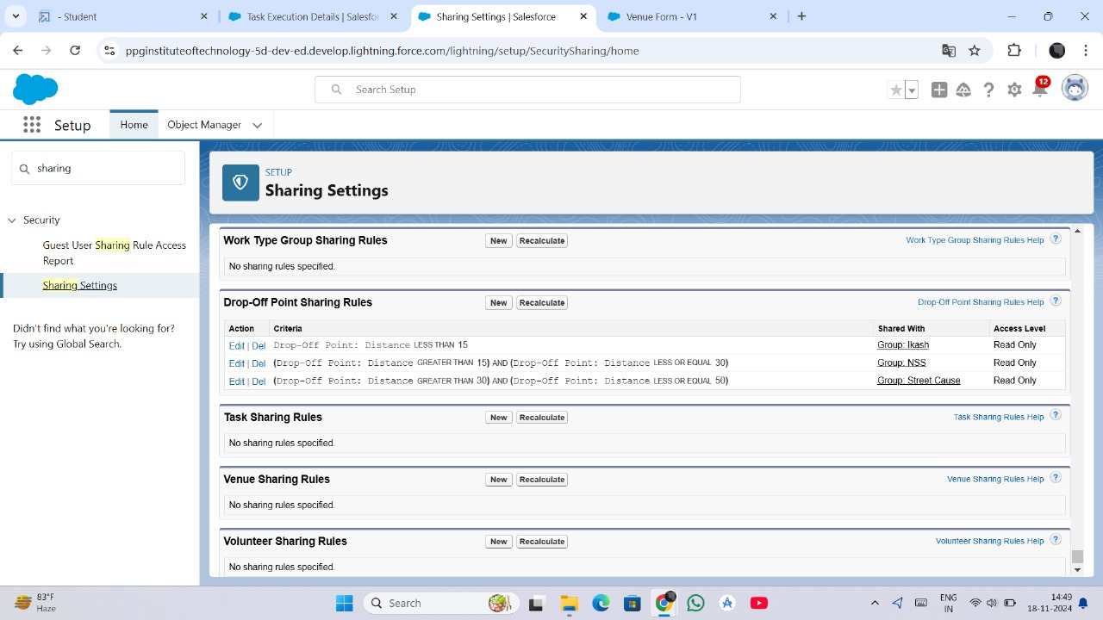

Sharing rules define the level of data access across users and groups. In the **"To Supply Leftover Food to the Poor"** project, sharing rules ensure that relevant stakeholders have access to important records.

**Steps:**

1. Go to **Setup** and search for **Sharing Settings**.
2. Click on **New Sharing Rule**.
3. **Define Rule Details**:
   * Choose the object (e.g., **Volunteer**, **Task**).
   * Define which users or public groups should have access to the records.
   * Set the access level (e.g., read-only, read/write).
4. **Save** and deploy the sharing rule.

**4. Creation of Home Page**

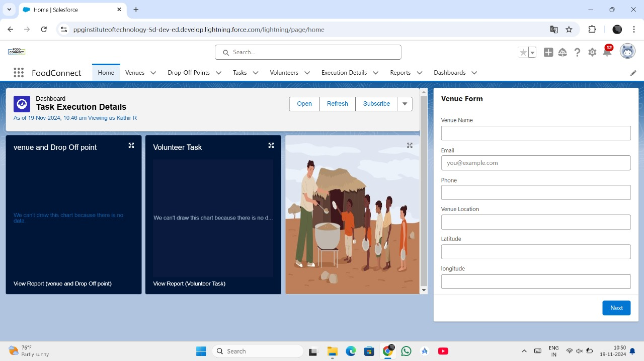

Customizing the home page in Salesforce helps to display relevant information for users, ensuring that they can quickly access the data they need.

**Steps:**

1. Go to **Setup** and search for **App Builder**.
2. Select **New** to create a new **Home Page**.
3. Choose a **Page Layout**.
4. **Add Components**: Drag and drop components such as:
   * Reports (e.g., Volunteer Task Report)
   * Charts
   * News (for project updates)
   * Recent Records (e.g., Task Status or Volunteer Assignments)
5. Customize the layout as per the user's role or function (NGO Managers, Volunteers, etc.).
6. Click **Save** and **Activate** the page.